

YOUNG PEOPLE’S GUIDE TO COMPLAINTS

[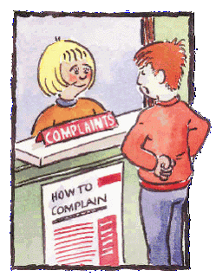](http://4.bp.blogspot.com/-JbhZYhhSGvQ/T0euozdFg9I/AAAAAAAAAig/M5Xqa1Hgcdc/s1600/complaint1.gif)

* First of all, make your key worker or any member of staff aware that you are not happy about something and you would like to make a complaint. In most cases, staff will be able to help resolve your concern, if not; all the information will be passed on to one of the managers. You will be told who the person is that is dealing with your complaint.
* Any member of staff can give you a complaints form.
* If you do not feel comfortable speaking to a member of staff or one of the managers, you can contact someone independent of Howard House.
* The timescale will be dependent on the type of complaint; however we will try to resolve all complaints within 7 days.
* At all times you will be kept informed of the progress being made in respect of your complaint. If at any time you feel that your complaint is not being dealt with properly, you are entitled to contact any one of the agencies listed on the next page.

**TELEPHONE NUMBERS YOU MIGHT FIND USEFUL**

North Tyneside Child Complaints Officer

Website: [www.northtyneside.gov.uk/custserv/complaints](http://www.northtyneside.gov.uk/custserv/complaints)

Email: [customerliasonoffice@northtyneside.gov.uk](mailto:customerliasonoffice@northtyneside.gov.uk)

0191 6432280

Durham Child Complaints Officer

0300 0265 762

Hartlepool Child Complaints Officer

01429 284020

Northumberland Child Complaints Officer

0800373615

Text 07766631901

Sunderland Child Complaints Officer

0191 561 1296

Newcastle Child Complaints Officer

0191 277 7427

There may be times where you feel that you are unable to speak to staff about things you are not happy with. If this is the case, there are other people who will be prepared to listen to what you have to say. Below is a list of external agencies and Ofsted who are there to help you the best they can.

Ofsted

P0 Box 4317

Manchester

M61 0AW

Tel: 0300 123 1231

Child Line

24 hour service

0800 1111

We would like to think you are happy with us at Howard House.

We hope that we are taking into account your needs, likes and dislikes in an appropriate manner.

We do recognise that there may be times when you feel that you have a complaint or grievance or that there is something you need to tell us about.

You do of course have the right to make a complaint and understand that the complaint will be dealt with the right way.

We would like to outline the route that you should take if you wish to make a complaint.

[](http://www.google.co.uk/url?sa=i&source=images&cd=&cad=rja&uact=8&docid=9zdksyJ3HUqtuM&tbnid=2TKytvL3Mqeq1M:&ved=0CAgQjRw4Mg&url=http://yaleherald.com/bullblog/let-your-voice-be-heard/&ei=19CFU5PcBeyB7Qae8oCADg&psig=AFQjCNGjG2Tg_wNqCAA1ysfFM8eLhJ6QBQ&ust=1401365079259039)

I agree that I have been given a copy of this leaflet and have been advised that I can speak to a member of staff at any time I feel the need to complain about something.

Signed: .....................

Date: ........................

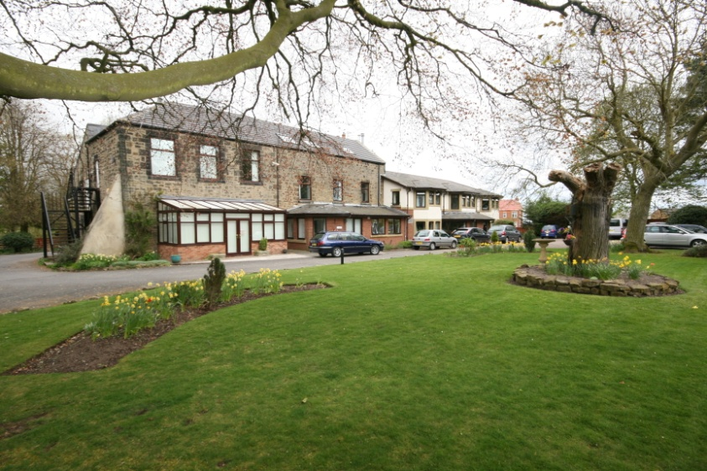

CONTACT DETAILS FOR HOWARD HOUSE TO PASS ON TO YOUR FAMILY AND FRIENDS

Howard House

Netherton Colliery

Bedlington

Northumberland

NE22 6BB

Telephone No: 01670 820320